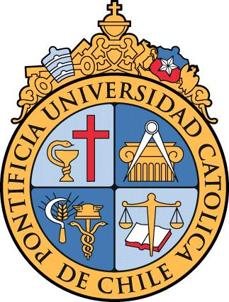

Departamento de Genética Molecular y Microbiología
Facultad de Ciencias Biológicas
P. Universidad Católica de Chile
Av. Libertador Bernardo O’Higgins 340.
Santiago de Chile

Seminar Series

Eukaryotic Gene Regulation and Functional Genomics

September 22nd, 2017 – Auditorio Abate Molina – P. Universidad Católica de Chile

Program

9:30 – 10:15 h Dr. Siobhan Brady
“Transcriptional regulation in the face of a changing environment”

10:15 – 11:00 h Dr. Luis Larrondo
“Gene expression through time and space”

11:00 – 11:45 h Dr. Rodrigo Gutiérrez
“Nitrate signaling and developmental responses in Arabidopsis thaliana”

11:45 Coffee

